SC_LMS_37 — Submit Ratings and Reviews
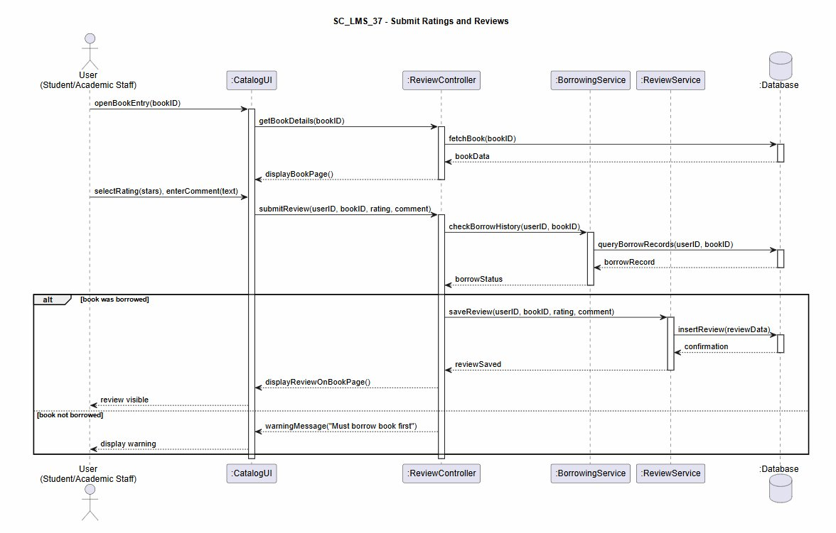

SC_LMS_38 — Provide System Feedback
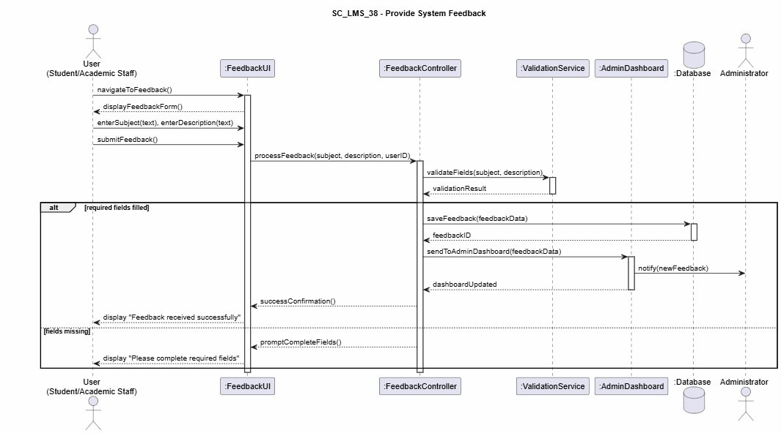

SC_LMS_39 — View Personalized Recommendations
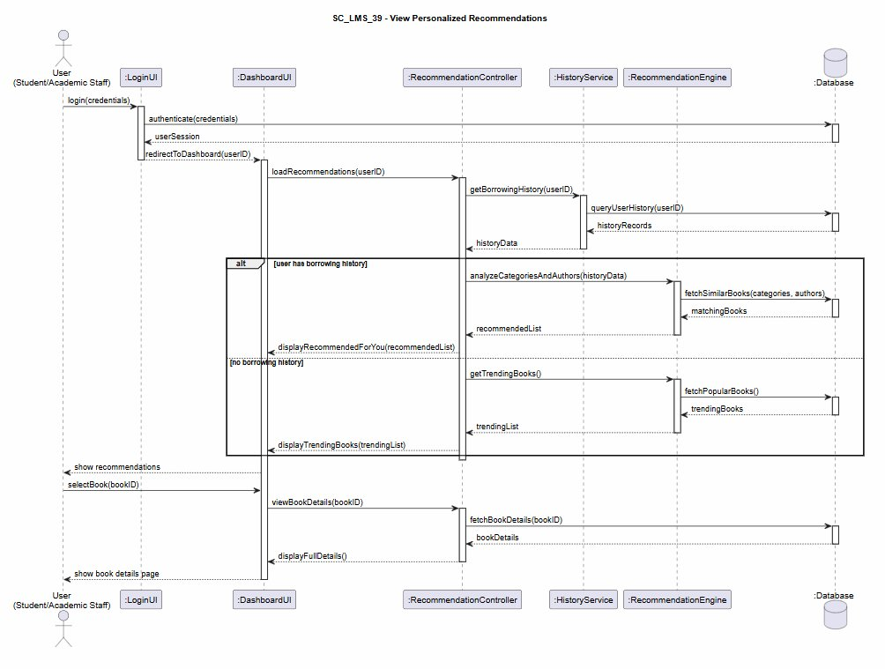

SC_LMS_40 — Manage Personal Wishlist
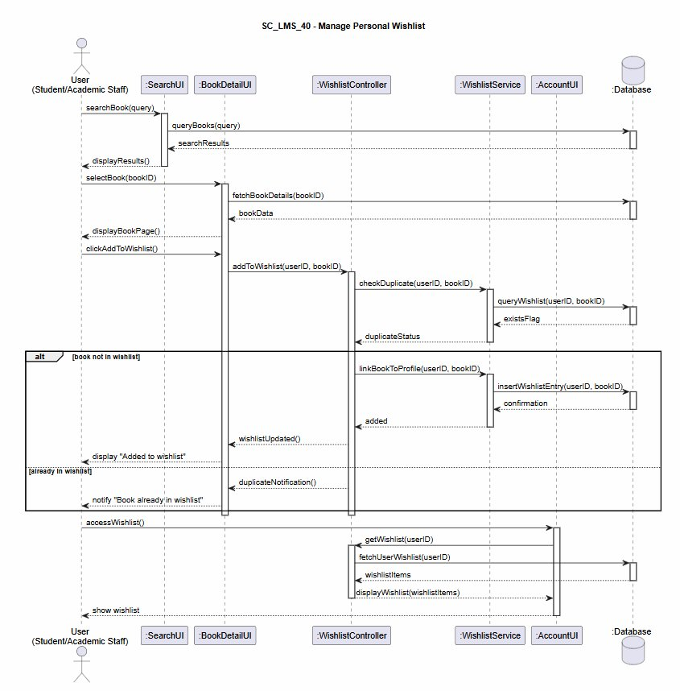

SC_LMS_41 — Respond to User Reviews
